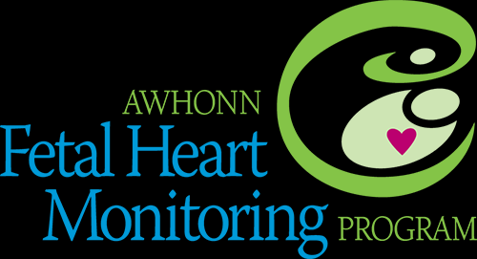

Advanced AWHONN Course
Workshop Description
This course is designed for perinatal clinicians who previously completed the AWHONN Intermediate Fetal Monitoring Course, a comparable fetal monitoring educational program and/or who hold certification or added credentials in fetal heart monitoring. May be used to support preparation for certification examinations.

This 1-day instructor-led course which was revised in 2017 is designed to prepare perinatal clinicians to care for patients with complex fetal heart monitoring tracings. Course components include:
- Complex case studies that include recommended interventions
- Communicating with colleagues
- Advanced principles of maternal-fetal physiology
- Optional online post-test is available

Intended Audience
This course is designed for perinatal clinicians who previously completed the AWHONN Intermediate Fetal Monitoring Course, a comparable fetal monitoring educational program and/or who hold certification or added credentials in fetal heart monitoring.
Fees
AWHONN Course fees $150. Instructor fees are not included in the AWHONN pricing for material fees.
Contact Hours
To obtain 8 contact hours of CNE and 6 hours of CME, participants must attend the entire course and complete an online feedback form.

Supporting Resources
The text entitled Fetal Heart Monitoring Principles & Practices is the primary reference for course preparation READ chapter 10 and 11.

REGISTRATION INFORMATION

Date: May 15th, 2020

Fee: $150.00 payable to: Perinatal Potpourri
Materials fee: $100.00 (plus tax, S & H) Payable to: Kendall/Hunt
Call 1-800-228-0810 or awhonn.kendallhunt.com/home
to order
Advanced AWHONN EFM Student Workbook
Course Number: 000A2020231
Time: 09:00 a.m. – 4:00 p.m.

Host: Zoom (link will be sent after payment)

Instructor Trainer: Lashea Haynes M.Ed., MSN, ACNS-BC, APRN, RNC, C-EFM
Contact info: 678-592-9330 cell
perinatalmentor@gmail.com or
awhonnatl@gmail.com

Deadline: registration with fee must be received before May 13th, 2020.
No refund, registration can be transferred to another participant and or another course.

REGISTRATION FORM

Name

Credentials

Title

Institution Affiliation

Home Address

City State Zip

Business Phone

Cell Phone

Email Address

AWHONN Membership Number

Make Checks Payable to: Perinatal Potpourri
1710 Branchwood court
Powder Springs, GA 30127

